Exodus –  
A People Moving Forward Together in Hope

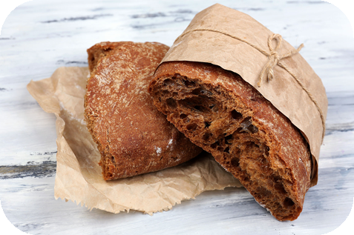

Food for the Journey

**Opening Responses**

Reader We gather in the name of the Father:

**All Who called to Moses from a burning bush**

**and called him to lead his people   
 into the future he was preparing for them.**

Reader We gather in the name of the Son:

**All Who celebrated Passover with his family and friends**

**and used its mix of sacrifice and meal  
 to give us the Eucharist.**

Reader We gather in the name of the Holy Spirit:

**All Who gives vision and courage to the People of God**

**as they respond to God’s call**

**to the Table of the Eucharist**

**and to take his grace into the world.**

**Remembering the Journey**

We will hear a couple of extracts from the Book of Exodus which tells us about the Passover Meal and the final plague which marked the beginning of the Journey for the Israelites and which Jesus would use as a setting for instituting the Eucharist.

**Thoughts for Reflection**

* What do you make of this part of the account? Don’t think too much about a “right” answer – just your reaction. You might like to think about – the importance of the meal – the part sacrifice plays – the idea of justice or vengeance…

*After the second extract:*

* What strikes you from this part of the account? The reaction of Pharaoh and the Egyptians? Or the “mixed crowd” –made up of all kinds of people? Or the fact that it came on them suddenly – even though Moses and Aaron had told them the day was coming? Or…?

**Exploring the Way**

Our reading has described a meal – a mixed crowd of people taking on various roles to get the people ready for the journey… or not getting ready for the journey! It takes a lot to get people to think about moving forward or changing – and many were unprepared. But enough were and had the wherewithal to share and survive what was to come.

Our questions for reflection from Forward Together in Hope come from the sections on *Active Involvement of People* and *Worship and Spiritual Life*.

**Looking at our community’s data.**

Information relevant to our reflective questions is presented to help our discussions.

**Reflective Questions**

* How diverse and active are parishioners within the community?
* How can the parish community invite and prepare more people to support it?
* Are there aspects of your community’s regular worship together at Mass that are working particularly well and deepen the spiritual life of those present?
* Is there anything your community can do to encourage a deeper prayer life and engagement with Scripture?



**Closing Prayer *Forward Together in Hope prayer***

**Glory be to the Father -**

**in whom we live and move**

**and have our being.**

**Glory be to the Son -**

**Whose name we bear**

**and who calls each of us**

**to be his disciples;**

**to build his Kingdom**

**and to go out into the world**

**and bear its fruit.**

**Glory be to the Holy Spirit -**

**pouring out grace and guidance,**

**forming us and renewing us.**

**Inspire us all**

**In the Diocese of Hexham and Newcastle**

**to live the Gospel,**

**to be open to change**

**and to move forward together in hope**

Hope Logo [Converted]Hope Logo [Converted]Hope Logo [Converted]